Ideation Phase

Define the Problem Statements

Date: June 28, 2025

Team ID: LTVIP2025TMID45560

Project Name: Revolutionizing Liver Care: Predicting Liver Cirrhosis using Advanced Machine Learning Techniques

Maximum Marks: 2 Marks

Customer Problem Statement Template:

A well-articulated customer problem statement allows you and your team to find the ideal solution for the challenges your customers face. Throughout the process, you'll also be able to empathize with your customers, which helps you better understand how they perceive your product or service.

Problem Statements Analysis
 | Problem |  |  |  |  | Which makes me
 | Statement | I am (Customer) | I'm trying to | But | Because | Which makes me
 | (PS) |  |  |  |  | feel
 | (PS) |  |  |  | traditional
 |  | A rural general |  | I have to rely on | diagnostic | frustrated and
 |  | A rural general | detect liver | expensive liver | diagnostic | worried that I'm
 |  | practitioner with | detect liver | expensive liver | methods are | worried that I'm
 |  | practitioner with | cirrhosis in my | biopsies and | methods are | missing critical
 | PS-1 | limited | patients at an | imaging scans that | invasive, costly, | cases that could
 |  | diagnostic | patients at an | imaging scans that | and not readily | cases that could
 |  | diagnostic | early stage | many patients | and not readily | be treated if
 |  | resources |  | cannot afford | available in my | caught early
 |  |  |  | cannot afford | clinic | caught early
 |  |  |  | I can't afford | these tests cost
 |  | A patient with | monitor my | frequent liver | thousands of | anxious about my
 |  | risk factors for | liver health | frequent liver | thousands of | health and
 |  | risk factors for | liver health | biopsies or | rupees and | health and
 | PS-2 | liver disease | regularly and | biopsies or | rupees and | helpless because I
 |  | (diabetes, | catch any | expensive scans, | require traveling | can't access
 |  | alcohol history) | problems early | and they're also | to specialized | proper monitoring
 |  |  |  | scary and painful | centers
 |  |  | efficiently |  | there's no | overworked and
 |  |  | efficiently | I'm overwhelmed | reliable pre- | overworked and
 |  |  | screen and | with referrals, many | screening tool to | concerned that
 |  | A hepatologist at | prioritize | of which turn out to | help primary | the current system
 | PS-3 | a tertiary care | patients | be unnecessary | care doctors | is failing both
 |  | hospital | referred for | be unnecessary | care doctors | patients and
 |  | hospital | referred for | while some critical | make better | patients and
 |  |  | liver disease | while some critical | make better | healthcare
 |  |  | evaluation | cases get delayed | referral | providers
 |  |  | evaluation |  | decisions | providers
 |  |  |  | traditional liver | liver biopsies, CT
 |  | A healthcare | provide quality | traditional liver | scans, and MRIs
 |  | A healthcare | provide quality | disease screening is | scans, and MRIs | pressured to
 |  | administrator | liver disease | disease screening is | cost significant | pressured to
 | PS-4 | managing a | care while | extremely | amounts per | balance quality
 | PS-4 | managing a | care while | expensive and | amounts per | care with financial
 |  | public hospital | controlling | expensive and | patient, limiting | care with financial
 |  | public hospital | controlling | strains our limited | patient, limiting | sustainability
 |  | budget | diagnostic costs | healthcare budget | access for the
 |  |  |  | healthcare budget | poor
 | PS-5 | A family member | understand if | the symptoms of | by the time | scared and
 |  | of someone at | my loved one | liver cirrhosis are | symptoms | helpless, wanting
 |  | risk for liver | needs urgent | often silent until it's | appear, the | to protect my
 |  | disease | medical | too late, and we | disease has | family but lacking
 |  |  | attention for | can't afford regular | often | accessible tools
 |  |  |  | expensive testing
Problem Statement

(PS)

I am (Customer)

I'm trying to

their liver

health

But
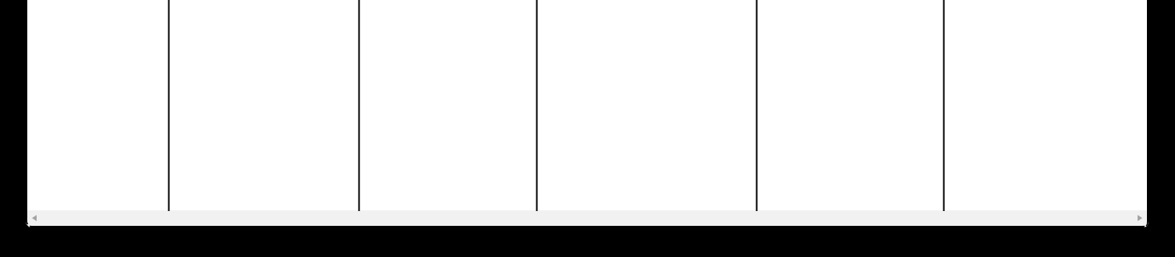

Because

progressed to

advanced stages

Which makes me feel

Key Problem Insights

Primary Pain Points Identified:

1. Cost Barrier: Traditional liver disease diagnostics are prohibitively expensive for many patients

2. Accessibility Gap: Advanced diagnostic tools are not available in rural/remote healthcare settings

3. Late Detection: Current methods often miss early-stage liver cirrhosis when it's most treatable

4. Resource Strain: Healthcare systems are overwhelmed with inefficient screening processes

5. Anxiety & Fear: Patients and families live with uncertainty due to lack of accessible monitoring tools

Target Customer Segments:

Primary: Rural and urban general practitioners

Secondary: Patients with liver disease risk factors

Tertiary: Healthcare administrators and specialists

Impact of Current Problems:

Delayed diagnosis leading to preventable deaths

Increased healthcare costs due to late-stage treatments

Reduced quality of life for patients and families

Inefficient allocation of healthcare resources

Widening health equity gaps between urban and rural populations

How Our Solution Addresses These Problems:

For Healthcare Providers (PS-1, PS-3, PS-4):

Non-invasive screening using readily available lab parameters

Cost-effective alternative to expensive imaging and biopsies

Quick results enabling immediate decision-making
Improved accuracy in referral decisions and resource allocation

For Patients and Families (PS-2, PS-5):

Affordable monitoring using basic blood tests

Early detection when treatment is most effective

Reduced anxiety through accessible health monitoring

Empowerment with actionable health information

System-Level Impact:

Resource optimization through better screening efficiency

Health equity improvement by making screening accessible

Cost reduction for healthcare systems and patients

Better outcomes through early intervention

Success Metrics Based on Problem Statements:

1. Diagnostic Accuracy: >90% accuracy in liver cirrhosis prediction

2. Cost Reduction: 80% reduction in screening costs compared to traditional methods

3. Accessibility: Deployable in resource-limited settings

4. Time Efficiency: Results available within minutes

5. User Satisfaction: High adoption rates among healthcare providers

6. Health Outcomes: Increased early-stage detection rates

Problem Statement Validation:

These problem statements are validated through:

Literature Review: Studies showing delayed liver disease diagnosis

Healthcare Data: Statistics on liver disease progression and costs

Expert Consultation: Insights from healthcare professionals

Real-world Context: Observations from Indian healthcare settings

Technology Trends: Growing adoption of AI in healthcare

This problem definition phase ensures our machine learning solution directly addresses real customer pain points rather than creating a solution in search of a problem.

